SKU | NAME | UPC | AVG RETAIL
PS2921 | Rivers Cut Pot Call | 0-10135 02921-0 | $124.95

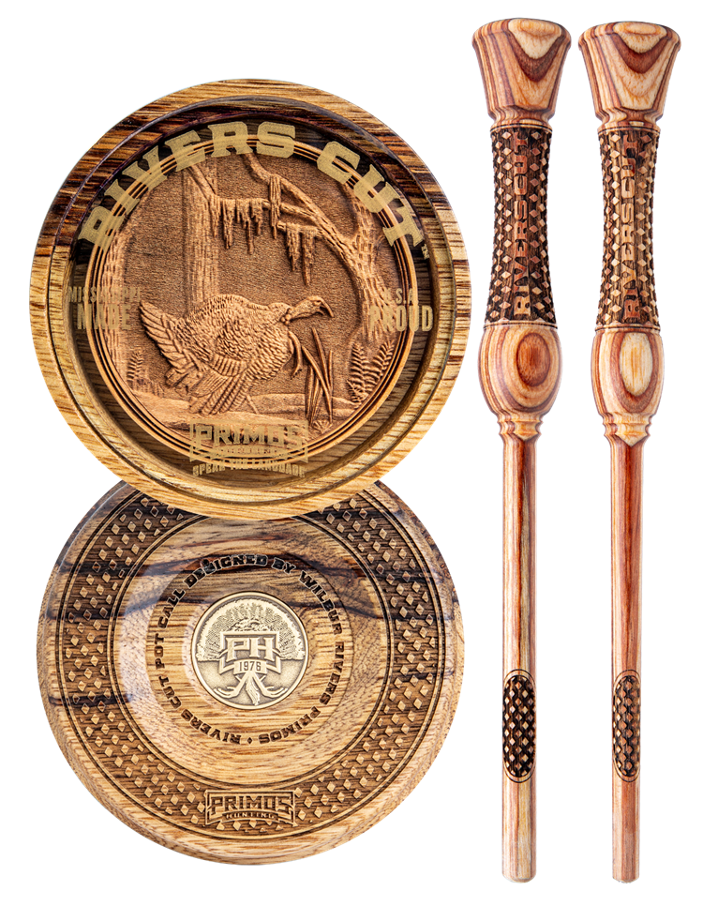
- Exotic hardwood hand selected by master call makers
- Intricate art, precision craftsmanship, and exceptional sound
- Two one-piece wood strikers with cut knurled guide for handling
- Available 12/1/19

Conceived from an unending desire to outwit. Designed by master call makers. Proven on the wild turkey. Primos brings to you the Rivers Cut Pot Call. Crafted from the most exotic woods, detailed with intricate engraving, and finished with a premium glass surface, the Rivers Cut finds its home in the woods or on the mantle. Originally designed for Wilbur Rivers Primos, The Rivers Cut proudly bears his name, and creates a sound only carefully selected hardwoods can produce. Tailor-made specifically for the River’s Cut Pot, come two strikers, each chosen to create a distinct tone. Both strikers hold a cut knurled guide made for the perfect finger placement while calling. Due to the rarity of these exotic woods, the River’s Cut Pot Call will only be available for a limited time.

